UNITED STATES
SECURITIES AND EXCHANGE COMMISSION
Washington, D.C. 20549

FORM 8-K

CURRENT REPORT

Pursuant to Section 13 or 15(d) of
The Securities Exchange Act of 1934

July 28, 2026
Date of Report (Date of earliest event reported)



O-I GLASS, INC.
(Exact name of registrant as specified in its charter)

Delaware |  | 1-9576 |  | 22-2781933
(State or other jurisdiction  of incorporation) |  | (Commission  File Number) |  | (IRS Employer  Identification No.)

One Michael Owens Way  Perrysburg, Ohio  (Address of principal executive offices) | 43551-2999  (Zip Code)

(567) 336-5000
(Registrant’s telephone number, including area code)

(Former name or former address, if changed since last report)

Check the appropriate box below if the Form 8-K filing is intended to simultaneously satisfy the filing obligation of the registrant under any of the following provisions:

☐ | Written communications pursuant to Rule 425 under the Securities Act (17 CFR 230.425)

☐ | Soliciting material pursuant to Rule 14a-12 under the Exchange Act (17 CFR 240.14a-12)

☐ | Pre-commencement communications pursuant to Rule 14d-2(b) under the Exchange Act (17 CFR 240.14d-2(b))

☐ | Pre-commencement communications pursuant to Rule 13e-4(c) under the Exchange Act (17 CFR 240.13e-4(c))

Securities registered pursuant to Section 12(b) of the Act:

Title of each class | Trading Symbol | Name of each exchange on which  registered
Common stock, $.01 par value | OI | New York Stock Exchange

Indicate by check mark whether the registrant is an emerging growth company as defined in Rule 405 of the Securities Act of 1933 (§230.405 of this chapter) or Rule 12b-2 of the Securities Exchange Act of 1934 (§240.12b-2 of this chapter).

Emerging growth company ☐

If an emerging growth company, indicate by check mark if the registrant has elected not to use the extended transition period for complying with any new or revised financial accounting standards provided pursuant to Section 13(a) of the Exchange Act. ☐

 | ITEM 2.02. | RESULTS OF OPERATIONS AND FINANCIAL CONDITION.

On July 28, 2026, O-I Glass, Inc. (the “Company”) issued a press release announcing its results of operations for the quarter ended June 30, 2026. A copy of the press release is attached hereto as Exhibit 99.1 and is incorporated herein by reference.

The information set forth in this Item 2.02, including Exhibit 99.1, is being furnished and shall not be deemed “filed” for purposes of Section 18 of the Securities Exchange Act of 1934, as amended (the “Exchange Act”) or otherwise subject to the liabilities of that Section. The information in this Item 2.02, including Exhibit 99.1, shall not be incorporated by reference into any filing of the Company under the Securities Act of 1933, as amended (the “Securities Act”), or the Exchange Act except as shall be expressly set forth by specific reference in such a filing.

 | ITEM 9.01 | FINANCIAL STATEMENTS AND EXHIBITS.

 | (d) | Exhibits.

Exhibit  No. |  | Description
99.1 |  | Press Release dated July 28, 2026 announcing results of operations for the quarter ended June 30, 2026
104 |  | Cover Page Interactive Data File (formatted as inline XBRL and contained in Exhibit 101)

SIGNATURES

Pursuant to the requirements of the Securities Exchange Act of 1934, the registrant has duly caused this report to be signed on its behalf by the undersigned hereunto duly authorized.

Date: July 28, 2026 | O-I GLASS, INC.
 | By: | /s/ John A. Haudrich
 |  | John A. Haudrich
 |  | Senior Vice President and Chief Financial Officer

Exhibit 99.1
 | 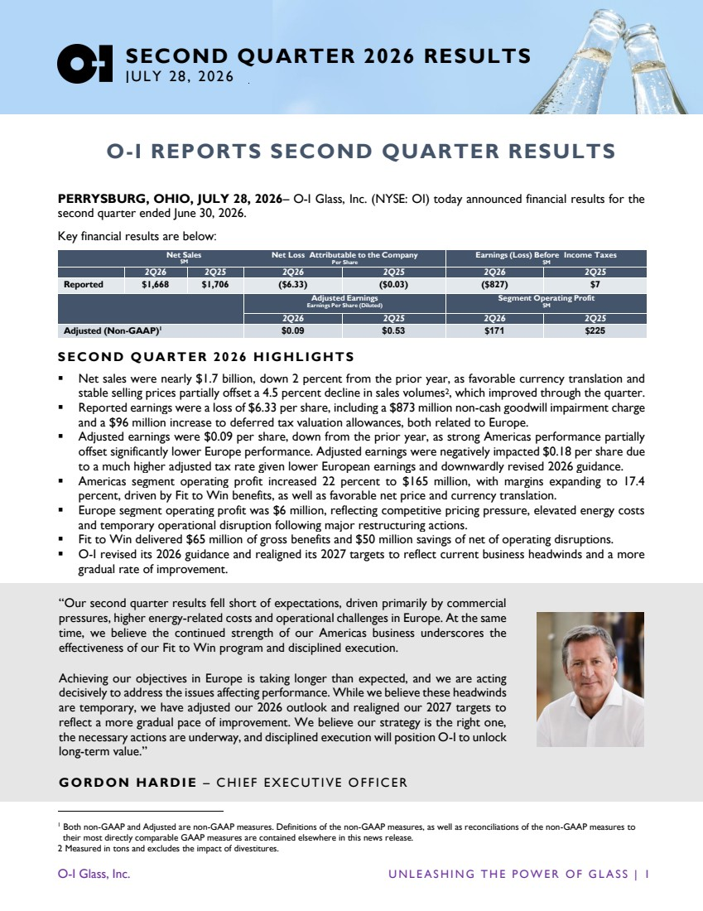 | O-I Glass, Inc. U N L E A S H I N G T H E P O W E R O F G L A S S | 1 SECOND QUARTER 2026 RESULTS JULY 28, 2026 O-I REPORTS SECOND QUARTER RESULTS PERRYSBURG, OHIO, JULY 28, 2026– O-I Glass, Inc. (NYSE: OI) today announced financial results for the second quarter ended June 30, 2026. Key financial results are below: Net Sales $M Net Loss Attributable to the Company Per Share Earnings (Loss) Before Income Taxes $M 2Q26 2Q25 2Q26 2Q25 2Q26 2Q25 Reported $1,668 $1,706 ($6.33) ($0.03) ($827) $7 Adjusted Earnings Earnings Per Share (Diluted) Segment Operating Profit $M 2Q26 2Q25 2Q26 2Q25 Adjusted (Non-GAAP)1 $0.09 $0.53 $171 $225 S ECOND QUART ER 2026 HIGHLIGHTS ▪ Net sales were nearly $1.7 billion, down 2 percent from the prior year, as favorable currency translation and stable selling prices partially offset a 4.5 percent decline in sales volumes2, which improved through the quarter. ▪ Reported earnings were a loss of $6.33 per share, including a $873 million non-cash goodwill impairment charge and a $96 million increase to deferred tax valuation allowances, both related to Europe. ▪ Adjusted earnings were $0.09 per share, down from the prior year, as strong Americas performance partially offset significantly lower Europe performance. Adjusted earnings were negatively impacted $0.18 per share due to a much higher adjusted tax rate given lower European earnings and downwardly revised 2026 guidance. ▪ Americas segment operating profit increased 22 percent to $165 million, with margins expanding to 17.4 percent, driven by Fit to Win benefits, as well as favorable net price and currency translation. ▪ Europe segment operating profit was $6 million, reflecting competitive pricing pressure, elevated energy costs and temporary operational disruption following major restructuring actions. ▪ Fit to Win delivered $65 million of gross benefits and $50 million savings of net of operating disruptions. ▪ O-I revised its 2026 guidance and realigned its 2027 targets to reflect current business headwinds and a more gradual rate of improvement. 1 Both non-GAAP and Adjusted are non-GAAP measures. Definitions of the non-GAAP measures, as well as reconciliations of the non-GAAP measures to their most directly comparable GAAP measures are contained elsewhere in this news release. 2 Measured in tons and excludes the impact of divestitures. “Our second quarter results fell short of expectations, driven primarily by competitive and operational challenges in Europe. We are acting decisively to address these issues. Encouragingly, we believe the continued strength of our Americas business highlights the effectiveness of our Fit to Win program and our disciplined approach to execution. Achieving our objectives in Europe is taking longer than expected due to persistent market challenges, including commercial pressures and higher energy related costs. While we believe these challenges are temporary, we have adjusted our 2026 outlook and realigned our 2027 targets to reflect a more gradual rate of improvement. We remain confident in our strategy, the actions we are taking, and our ability to create long-term value.” GORDON HARDI E – CHI EF EXE CUTIVE O FF ICER “Our second quarter results fell short of expectations, driven primarily by commercial pressures, higher energy-related costs and operational challenges in Europe. At the same time, we believe the continued strength of our Americas business underscores the effectiveness of our Fit to Win program and disciplined execution. Achieving our objectives in Europe is taking longer than expected, and we are acting decisively to address the issues affecting performance. While we believe these headwinds are temporary, we have adjusted our 2026 outlook and realigned our 2027 targets to reflect a more gradual pace of improvement. We believe our strategy is the right one, the necessary actions are underway, and disciplined execution will position O-I to unlock long-term value.” GORDON HARDI E – CHI EF EXE CUTIVE O FF ICER
 | 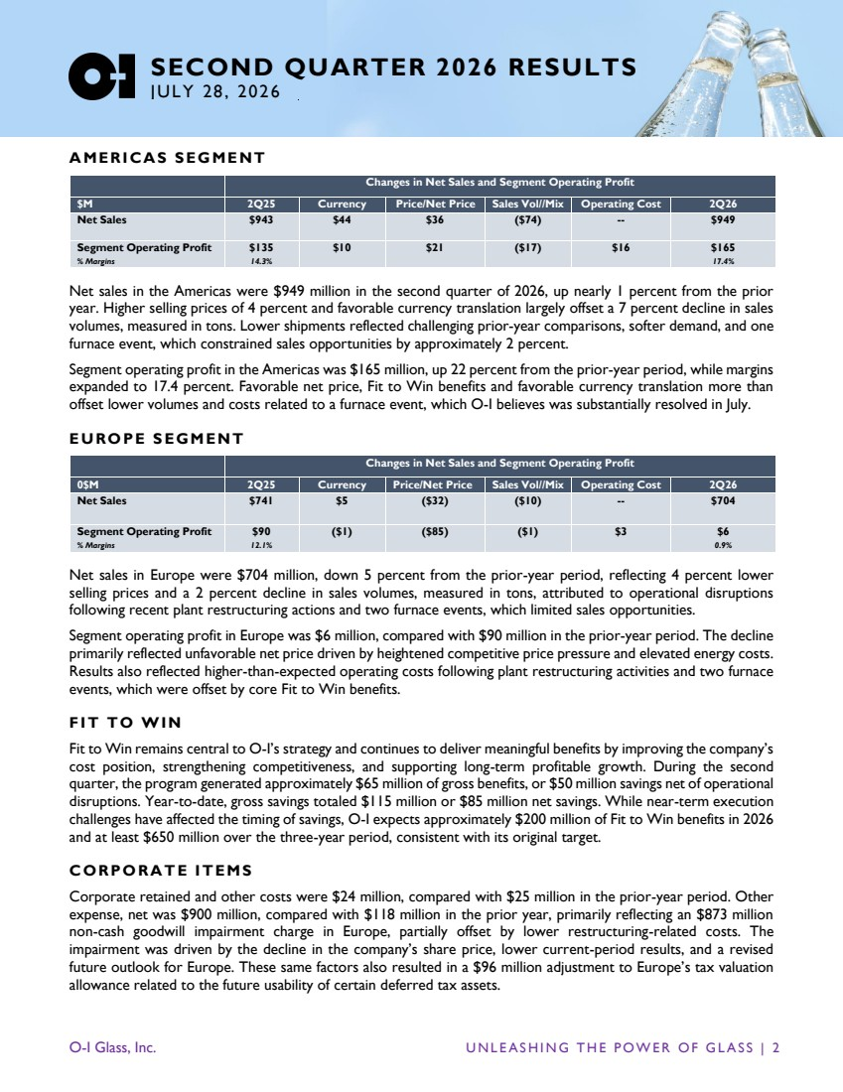 | O-I Glass, Inc. U N L E A S H I N G T H E P O W E R O F G L A S S | 2 SECOND QUARTER 2026 RESULTS JULY 28, 2026 A MERICAS S EGMENT Changes in Net Sales and Segment Operating Profit $M 2Q25 Currency Price/Net Price Sales Vol//Mix Operating Cost 2Q26 Net Sales $943 $44 $36 ($74) -- $949 Segment Operating Profit % Margins $135 14.3% $10 $21 ($17) $16 $165 17.4% Net sales in the Americas were $949 million in the second quarter of 2026, up nearly 1 percent from the prior year. Higher selling prices of 4 percent and favorable currency translation largely offset a 7 percent decline in sales volumes, measured in tons. Lower shipments reflected challenging prior-year comparisons, softer demand, and one furnace event, which constrained sales opportunities by approximately 2 percent. Segment operating profit in the Americas was $165 million, up 22 percent from the prior-year period, while margins expanded to 17.4 percent. Favorable net price, Fit to Win benefits and favorable currency translation more than offset lower volumes and costs related to a furnace event, which O-I believes was substantially resolved in July. EURO PE S EGMENT Changes in Net Sales and Segment Operating Profit 0$M 2Q25 Currency Price/Net Price Sales Vol//Mix Operating Cost 2Q26 Net Sales $741 $5 ($32) ($10) -- $704 Segment Operating Profit % Margins $90 12.1% ($1) ($85) ($1) $3 $6 0.9% Net sales in Europe were $704 million, down 5 percent from the prior-year period, reflecting 4 percent lower selling prices and a 2 percent decline in sales volumes, measured in tons, attributed to operational disruptions following recent plant restructuring actions and two furnace events, which limited sales opportunities. Segment operating profit in Europe was $6 million, compared with $90 million in the prior-year period. The decline primarily reflected unfavorable net price driven by heightened competitive price pressure and elevated energy costs. Results also reflected higher-than-expected operating costs following plant restructuring activities and two furnace events, which were offset by core Fit to Win benefits. FIT TO WIN Fit to Win remains central to O-I’s strategy and continues to deliver meaningful benefits by improving the company’s cost position, strengthening competitiveness, and supporting long-term profitable growth. During the second quarter, the program generated approximately $65 million of gross benefits, or $50 million savings net of operational disruptions. Year-to-date, gross savings totaled $115 million or $85 million net savings. While near-term execution challenges have affected the timing of savings, O-I expects approximately $200 million of Fit to Win benefits in 2026 and at least $650 million over the three-year period, consistent with its original target. CORPORA T E IT EMS Corporate retained and other costs were $24 million, compared with $25 million in the prior-year period. Other expense, net was $900 million, compared with $118 million in the prior year, primarily reflecting an $873 million non-cash goodwill impairment charge in Europe, partially offset by lower restructuring-related costs. The impairment was driven by the decline in the company’s share price, lower current-period results, and a revised future outlook for Europe. These same factors also resulted in a $96 million adjustment to Europe’s tax valuation allowance related to the future usability of certain deferred tax assets.
 | 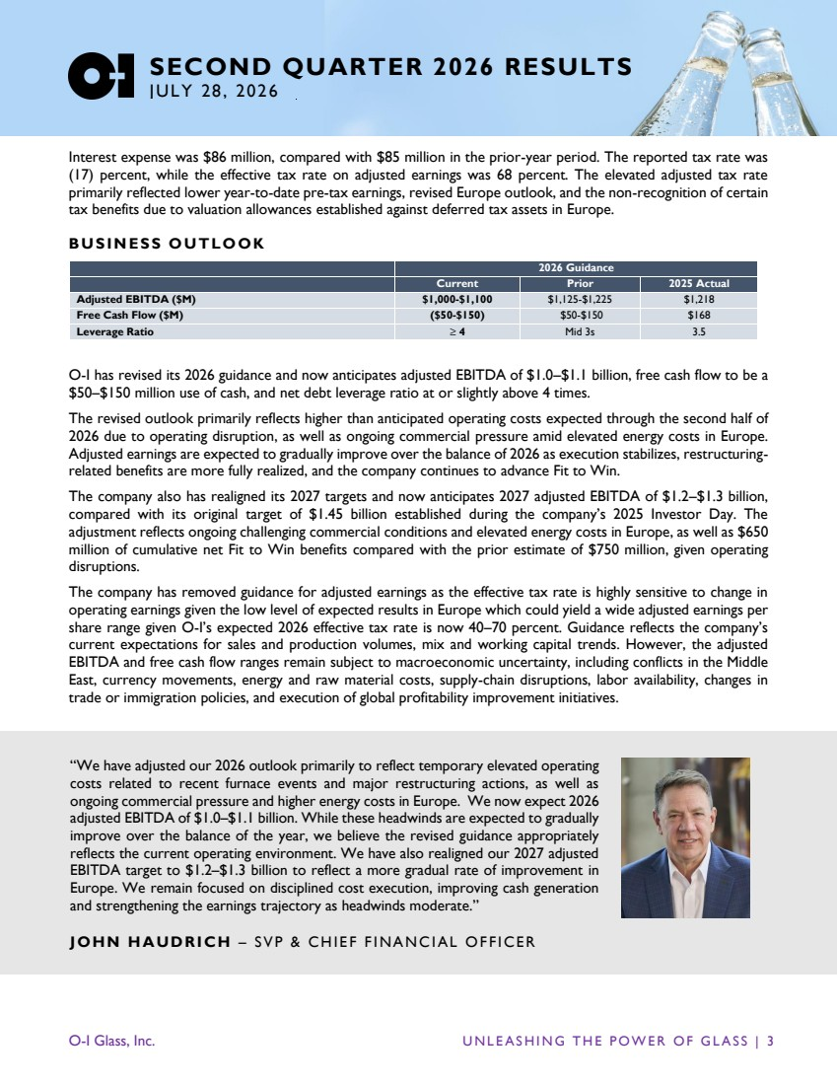 | O-I Glass, Inc. U N L E A S H I N G T H E P O W E R O F G L A S S | 3 SECOND QUARTER 2026 RESULTS JULY 28, 2026 Interest expense was $86 million, compared with $85 million in the prior-year period. The reported tax rate was (17) percent, while the effective tax rate on adjusted earnings was 68 percent. The elevated adjusted tax rate primarily reflected lower year-to-date pre-tax earnings, revised Europe outlook, and the non-recognition of certain tax benefits due to valuation allowances established against deferred tax assets in Europe. BUSIN ESS OUTLOOK 2026 Guidance Current Prior 2025 Actual Adjusted EBITDA ($M) $1,000-$1,100 $1,125-$1,225 $1,218 Free Cash Flow ($M) ($50-$150) $50-$150 $168 Leverage Ratio ≥ 4 Mid 3s 3.5 O-I has revised its 2026 guidance and now anticipates adjusted EBITDA of $1.0–$1.1 billion, free cash flow to be a $50–$150 million use of cash, and net debt leverage ratio at or slightly above 4 times. The revised outlook primarily reflects higher than anticipated operating costs expected through the second half of 2026 due to operating disruption, as well as ongoing commercial pressure amid elevated energy costs in Europe. Adjusted earnings are expected to gradually improve over the balance of 2026 as execution stabilizes, restructuring-related benefits are more fully realized, and the company continues to advance Fit to Win. The company also has realigned its 2027 targets and now anticipates 2027 adjusted EBITDA of $1.2–$1.3 billion, compared with its original target of $1.45 billion established during the company’s 2025 Investor Day. The adjustment reflects ongoing challenging commercial conditions and elevated energy costs in Europe, as well as $650 million of cumulative net Fit to Win benefits compared with the prior estimate of $750 million, given operating disruptions. The company has removed guidance for adjusted earnings as the effective tax rate is highly sensitive to change in operating earnings given the low level of expected results in Europe which could yield a wide adjusted earnings per share range given O-I’s expected 2026 effective tax rate is now 40–70 percent. Guidance reflects the company’s current expectations for sales and production volumes, mix and working capital trends. However, the adjusted EBITDA and free cash flow ranges remain subject to macroeconomic uncertainty, including conflicts in the Middle East, currency movements, energy and raw material costs, supply-chain disruptions, labor availability, changes in trade or immigration policies, and execution of global profitability improvement initiatives. “We have adjusted our 2026 outlook primarily to reflect temporary elevated operating costs related to recent furnace events and major restructuring actions, as well as ongoing commercial pressure and higher energy costs in Europe. We now expect 2026 adjusted EBITDA of $1.0–$1.1 billion. While these headwinds are expected to gradually improve over the balance of the year, we believe the revised guidance appropriately reflects the current operating environment. We have also realigned our 2027 adjusted EBITDA target to $1.2–$1.3 billion to reflect a more gradual rate of improvement in Europe. We remain focused on disciplined cost execution, improving cash generation and strengthening the earnings trajectory as headwinds moderate.” JOHN HAUDRICH – SVP & CH IE F F INANC IAL OF FIC ER
 | 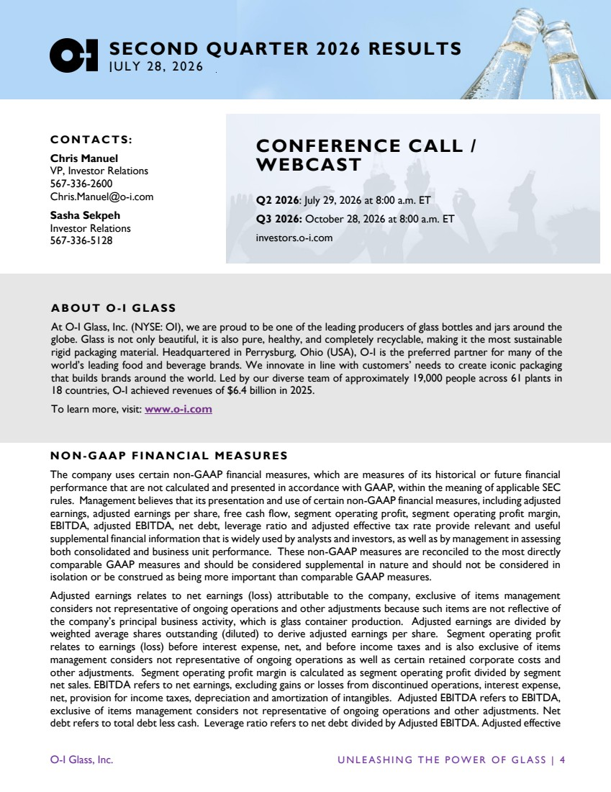 | O-I Glass, Inc. U N L E A S H I N G T H E P O W E R O F G L A S S | 4 SECOND QUARTER 2026 RESULTS JULY 28, 2026 CONTAC TS: Chris Manuel VP, Investor Relations 567-336-2600 Chris.Manuel@o-i.com Sasha Sekpeh Investor Relations 567-336-5128 NON-GAAP FINANCIAL MEASU RES The company uses certain non-GAAP financial measures, which are measures of its historical or future financial performance that are not calculated and presented in accordance with GAAP, within the meaning of applicable SEC rules. Management believes that its presentation and use of certain non-GAAP financial measures, including adjusted earnings, adjusted earnings per share, free cash flow, segment operating profit, segment operating profit margin, EBITDA, adjusted EBITDA, net debt, leverage ratio and adjusted effective tax rate provide relevant and useful supplemental financial information that is widely used by analysts and investors, as well as by management in assessing both consolidated and business unit performance. These non-GAAP measures are reconciled to the most directly comparable GAAP measures and should be considered supplemental in nature and should not be considered in isolation or be construed as being more important than comparable GAAP measures. Adjusted earnings relates to net earnings (loss) attributable to the company, exclusive of items management considers not representative of ongoing operations and other adjustments because such items are not reflective of the company’s principal business activity, which is glass container production. Adjusted earnings are divided by weighted average shares outstanding (diluted) to derive adjusted earnings per share. Segment operating profit relates to earnings (loss) before interest expense, net, and before income taxes and is also exclusive of items management considers not representative of ongoing operations as well as certain retained corporate costs and other adjustments. Segment operating profit margin is calculated as segment operating profit divided by segment net sales. EBITDA refers to net earnings, excluding gains or losses from discontinued operations, interest expense, net, provision for income taxes, depreciation and amortization of intangibles. Adjusted EBITDA refers to EBITDA, exclusive of items management considers not representative of ongoing operations and other adjustments. Net debt refers to total debt less cash. Leverage ratio refers to net debt divided by Adjusted EBITDA. Adjusted effective A BOUT O-I GLASS At O-I Glass, Inc. (NYSE: OI), we are proud to be one of the leading producers of glass bottles and jars around the globe. Glass is not only beautiful, it is also pure, healthy, and completely recyclable, making it the most sustainable rigid packaging material. Headquartered in Perrysburg, Ohio (USA), O-I is the preferred partner for many of the world’s leading food and beverage brands. We innovate in line with customers’ needs to create iconic packaging that builds brands around the world. Led by our diverse team of approximately 19,000 people across 61 plants in 18 countries, O-I achieved revenues of $6.4 billion in 2025. To learn more, visit: www.o-i.com CONFERENCE CALL / WEBCAST Q2 2026: July 29, 2026 at 8:00 a.m. ET Q3 2026: October 28, 2026 at 8:00 a.m. ET investors.o-i.com
 | 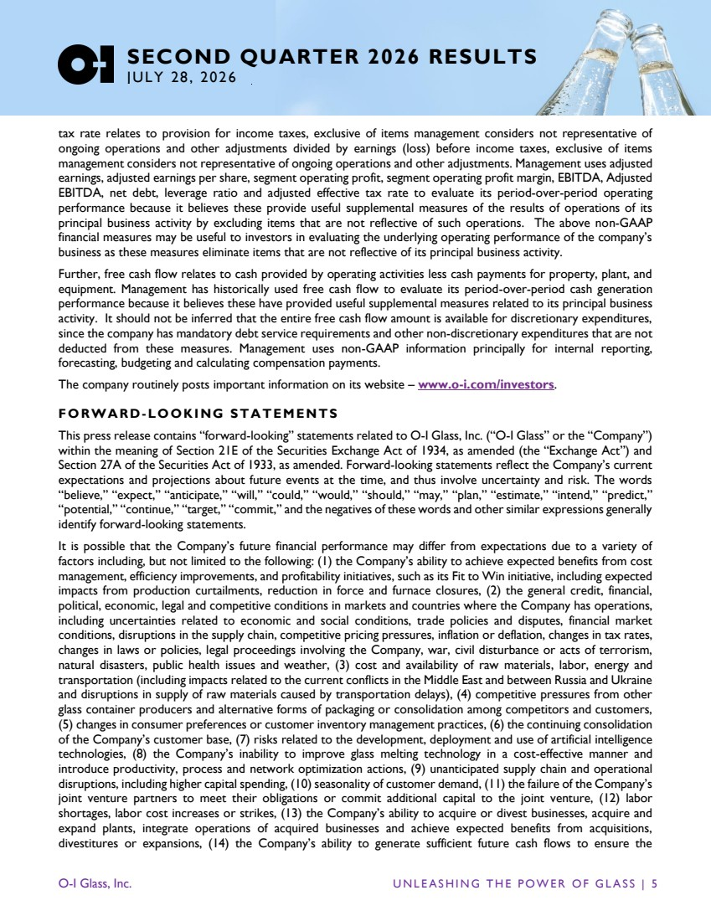 | O-I Glass, Inc. U N L E A S H I N G T H E P O W E R O F G L A S S | 5 SECOND QUARTER 2026 RESULTS JULY 28, 2026 tax rate relates to provision for income taxes, exclusive of items management considers not representative of ongoing operations and other adjustments divided by earnings (loss) before income taxes, exclusive of items management considers not representative of ongoing operations and other adjustments. Management uses adjusted earnings, adjusted earnings per share, segment operating profit, segment operating profit margin, EBITDA, Adjusted EBITDA, net debt, leverage ratio and adjusted effective tax rate to evaluate its period-over-period operating performance because it believes these provide useful supplemental measures of the results of operations of its principal business activity by excluding items that are not reflective of such operations. The above non-GAAP financial measures may be useful to investors in evaluating the underlying operating performance of the company’s business as these measures eliminate items that are not reflective of its principal business activity. Further, free cash flow relates to cash provided by operating activities less cash payments for property, plant, and equipment. Management has historically used free cash flow to evaluate its period-over-period cash generation performance because it believes these have provided useful supplemental measures related to its principal business activity. It should not be inferred that the entire free cash flow amount is available for discretionary expenditures, since the company has mandatory debt service requirements and other non-discretionary expenditures that are not deducted from these measures. Management uses non-GAAP information principally for internal reporting, forecasting, budgeting and calculating compensation payments. The company routinely posts important information on its website – www.o-i.com/investors. FORWARD -LOOKING STA TEMENTS This press release contains “forward-looking” statements related to O-I Glass, Inc. (“O-I Glass” or the “Company”) within the meaning of Section 21E of the Securities Exchange Act of 1934, as amended (the “Exchange Act”) and Section 27A of the Securities Act of 1933, as amended. Forward-looking statements reflect the Company’s current expectations and projections about future events at the time, and thus involve uncertainty and risk. The words “believe,” “expect,” “anticipate,” “will,” “could,” “would,” “should,” “may,” “plan,” “estimate,” “intend,” “predict,” “potential,” “continue,” “target,” “commit,” and the negatives of these words and other similar expressions generally identify forward-looking statements. It is possible that the Company’s future financial performance may differ from expectations due to a variety of factors including, but not limited to the following: (1) the Company’s ability to achieve expected benefits from cost management, efficiency improvements, and profitability initiatives, such as its Fit to Win initiative, including expected impacts from production curtailments, reduction in force and furnace closures, (2) the general credit, financial, political, economic, legal and competitive conditions in markets and countries where the Company has operations, including uncertainties related to economic and social conditions, trade policies and disputes, financial market conditions, disruptions in the supply chain, competitive pricing pressures, inflation or deflation, changes in tax rates, changes in laws or policies, legal proceedings involving the Company, war, civil disturbance or acts of terrorism, natural disasters, public health issues and weather, (3) cost and availability of raw materials, labor, energy and transportation (including impacts related to the current conflicts in the Middle East and between Russia and Ukraine and disruptions in supply of raw materials caused by transportation delays), (4) competitive pressures from other glass container producers and alternative forms of packaging or consolidation among competitors and customers, (5) changes in consumer preferences or customer inventory management practices, (6) the continuing consolidation of the Company’s customer base, (7) risks related to the development, deployment and use of artificial intelligence technologies, (8) the Company’s inability to improve glass melting technology in a cost-effective manner and introduce productivity, process and network optimization actions, (9) unanticipated supply chain and operational disruptions, including higher capital spending, (10) seasonality of customer demand, (11) the failure of the Company’s joint venture partners to meet their obligations or commit additional capital to the joint venture, (12) labor shortages, labor cost increases or strikes, (13) the Company’s ability to acquire or divest businesses, acquire and expand plants, integrate operations of acquired businesses and achieve expected benefits from acquisitions, divestitures or expansions, (14) the Company’s ability to generate sufficient future cash flows to ensure the
 | 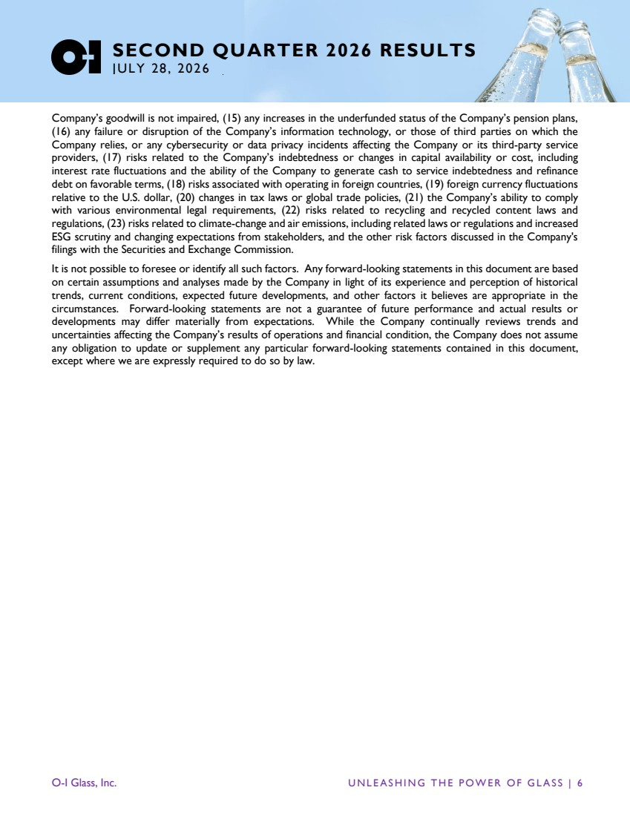 | O-I Glass, Inc. U N L E A S H I N G T H E P O W E R O F G L A S S | 6 SECOND QUARTER 2026 RESULTS JULY 28, 2026 Company’s goodwill is not impaired, (15) any increases in the underfunded status of the Company’s pension plans, (16) any failure or disruption of the Company’s information technology, or those of third parties on which the Company relies, or any cybersecurity or data privacy incidents affecting the Company or its third-party service providers, (17) risks related to the Company’s indebtedness or changes in capital availability or cost, including interest rate fluctuations and the ability of the Company to generate cash to service indebtedness and refinance debt on favorable terms, (18) risks associated with operating in foreign countries, (19) foreign currency fluctuations relative to the U.S. dollar, (20) changes in tax laws or global trade policies, (21) the Company’s ability to comply with various environmental legal requirements, (22) risks related to recycling and recycled content laws and regulations, (23) risks related to climate-change and air emissions, including related laws or regulations and increased ESG scrutiny and changing expectations from stakeholders, and the other risk factors discussed in the Company's filings with the Securities and Exchange Commission. It is not possible to foresee or identify all such factors. Any forward-looking statements in this document are based on certain assumptions and analyses made by the Company in light of its experience and perception of historical trends, current conditions, expected future developments, and other factors it believes are appropriate in the circumstances. Forward-looking statements are not a guarantee of future performance and actual results or developments may differ materially from expectations. While the Company continually reviews trends and uncertainties affecting the Company’s results of operations and financial condition, the Company does not assume any obligation to update or supplement any particular forward-looking statements contained in this document, except where we are expressly required to do so by law.

O-I GLASS, INC.
Condensed Consolidated Results of Operations
(Dollars in millions, except per share amounts)

 |  | Three months ended  June 30 |  |  |  |  |  |  |  | Six months ended  June 30
Unaudited |  | 2026 |  |  |  | 2025 |  |  |  | 2026 |  |  |  | 2025
Net sales |  | $ | 1,668 |  |  | $ | 1,706 |  |  | $ | 3,207 |  |  | $ | 3,273
Cost of goods sold |  |  | (1,454 | ) |  |  | (1,407 | ) |  |  | (2,794 | ) |  |  | (2,694 | )
Gross profit |  |  | 214 |  |  |  | 299 |  |  |  | 413 |  |  |  | 579
Selling and administrative expense |  |  | (75 | ) |  |  | (106 | ) |  |  | (173 | ) |  |  | (213 | )
Research, development and engineering expense |  |  | (9 | ) |  |  | (11 | ) |  |  | (19 | ) |  |  | (25 | )
Interest expense, net |  |  | (86 | ) |  |  | (85 | ) |  |  | (165 | ) |  |  | (166 | )
Equity earnings |  |  | 29 |  |  |  | 28 |  |  |  | 55 |  |  |  | 51
Other expense, net (incl. goodwill impairment) |  |  | (900 | ) |  |  | (118 | ) |  |  | (991 | ) |  |  | (200 | )
Earnings (loss) before income taxes |  |  | (827 | ) |  |  | 7 |  |  |  | (880 | ) |  |  | 26
Provision for income taxes |  |  | (138 | ) |  |  | (6 | ) |  |  | (156 | ) |  |  | (36 | )
Net earnings (loss) |  |  | (965 | ) |  |  | 1 |  |  |  | (1,036 | ) |  |  | (10 | )
Net earnings attributable to noncontrolling interests |  |  | (7 | ) |  |  | (6 | ) |  |  | (10 | ) |  |  | (10 | )
Net loss attributable to the Company |  | $ | (972 | ) |  | $ | (5 | ) |  | $ | (1,046 | ) |  | $ | (20 | )
Basic earnings per share:
Net loss attributable to the Company |  | $ | (6.33 | ) |  | $ | (0.03 | ) |  | $ | (6.83 | ) |  | $ | (0.13 | )
Weighted average shares outstanding (thousands) |  |  | 153,498 |  |  |  | 153,993 |  |  |  | 153,093 |  |  |  | 153,851
Diluted earnings per share:
Net loss attributable to the Company |  | $ | (6.33 | ) |  | $ | (0.03 | ) |  | $ | (6.83 | ) |  | $ | (0.13 | )
Diluted average shares (thousands) |  |  | 153,498 |  |  |  | 153,993 |  |  |  | 153,093 |  |  |  | 153,851

O-I GLASS, INC.
Condensed Consolidated Balance Sheets
(Dollars in millions)

Unaudited |  | June 30, |  |  |  | December 31, |  |  |  | June 30,
 |  | 2026 |  |  |  | 2025 |  |  |  | 2025
Assets
Current assets:
Cash and cash equivalents |  | $ | 339 |  |  | $ | 759 |  |  | $ | 487
Trade receivables, net |  |  | 883 |  |  |  | 601 |  |  |  | 848
Inventories |  |  | 947 |  |  |  | 1,002 |  |  |  | 990
Prepaid expenses and other current assets |  |  | 282 |  |  |  | 239 |  |  |  | 279
Total current assets |  |  | 2,451 |  |  |  | 2,601 |  |  |  | 2,604
Property, plant and equipment, net |  |  | 3,451 |  |  |  | 3,447 |  |  |  | 3,458
Goodwill |  |  | 608 |  |  |  | 1,487 |  |  |  | 1,467
Intangibles, net |  |  | 178 |  |  |  | 188 |  |  |  | 196
Other assets |  |  | 1,400 |  |  |  | 1,520 |  |  |  | 1,454
Total assets |  | $ | 8,088 |  |  | $ | 9,243 |  |  | $ | 9,179
Liabilities and Share Owners' Equity
Current liabilities:
Accounts payable |  | $ | 1,090 |  |  | $ | 1,201 |  |  | $ | 1,104
Short-term loans and long-term debt due within one year |  |  | 193 |  |  |  | 162 |  |  |  | 236
Other liabilities |  |  | 661 |  |  |  | 726 |  |  |  | 762
Total current liabilities |  |  | 1,944 |  |  |  | 2,089 |  |  |  | 2,102
Long-term debt |  |  | 4,793 |  |  |  | 4,837 |  |  |  | 4,898
Other long-term liabilities |  |  | 812 |  |  |  | 872 |  |  |  | 810
Share owners' equity |  |  | 539 |  |  |  | 1,445 |  |  |  | 1,369
Total liabilities and share owners' equity |  | $ | 8,088 |  |  | $ | 9,243 |  |  | $ | 9,179

O-I GLASS, INC.
Condensed Consolidated Cash Flows
(Dollars in millions)

Unaudited |  | Three months ended  June 30 |  |  |  |  |  |  |  | Six months ended  June 30
 |  | 2026 |  |  |  | 2025 |  |  |  | 2026 |  |  |  | 2025
Cash flows from operating activities:
Net earnings (loss) |  | $ | (965 | ) |  | $ | 1 |  |  | $ | (1,036 | ) |  | $ | (10 | )
Non-cash charges
Depreciation and amortization |  |  | 122 |  |  |  | 120 |  |  |  | 241 |  |  |  | 238
Pension expense |  |  | 8 |  |  |  | 8 |  |  |  | 17 |  |  |  | 15
Stock-based compensation expense |  |  |  |  |  |  | 4 |  |  |  | 5 |  |  |  | 8
Goodwill impairment |  |  | 873 |  |  |  |  |  |  |  | 873
Change in European valuation allowance on deferred tax assets |  |  | 96 |  |  |  |  |  |  |  | 96
Restructuring, asset impairment and related charges |  |  | 17 |  |  |  | 113 |  |  |  | 55 |  |  |  | 195
Legacy environmental charge |  |  |  |  |  |  |  |  |  |  |  |  |  |  | 4
(Gain) loss on sale of joint venture and miscellaneous assets |  |  | (2 | ) |  |  |  |  |  |  | 44 |  |  |  | (6 | )
Cash payments
Pension contributions |  |  | (5 | ) |  |  | (7 | ) |  |  | (15 | ) |  |  | (14 | )
Cash paid for restructuring activities |  |  | (55 | ) |  |  | (50 | ) |  |  | (90 | ) |  |  | (78 | )
Change in components of working capital (a) |  |  | (5 | ) |  |  | (21 | ) |  |  | (381 | ) |  |  | (335 | )
Other, net (b) |  |  | 10 |  |  |  | (13 | ) |  |  | (9 | ) |  |  | (33 | )
Cash provided by (utilized in) operating activities |  |  | 94 |  |  |  | 155 |  |  |  | (200 | ) |  |  | (16 | )
Cash flows from investing activities:
Cash payments for property, plant and equipment |  |  | (95 | ) |  |  | (104 | ) |  |  | (237 | ) |  |  | (239 | )
Net cash proceeds on sale of joint venture and misc. assets |  |  | 2 |  |  |  | 5 |  |  |  | 7 |  |  |  | 18
Net cash payments from hedging activities |  |  |  |  |  |  | (2 | ) |  |  | (2 | )
Cash utilized in investing activities |  |  | (93 | ) |  |  | (101 | ) |  |  | (232 | ) |  |  | (221 | )
Cash flows from financing activities:
Changes in borrowings, net |  |  | 36 |  |  |  | 10 |  |  |  | 31 |  |  |  | (6 | )
Shares repurchased |  |  |  |  |  |  | (10 | ) |  |  | (10 | ) |  |  | (20 | )
Payment of finance fees |  |  | (7 | ) |  |  |  |  |  |  | (7 | )
Net cash receipts (payments) for hedging activity |  |  | 2 |  |  |  | (6 | ) |  |  | 2 |  |  |  | (6 | )
Distributions to non-controlling interests |  |  | (12 | ) |  |  | (8 | ) |  |  | (12 | ) |  |  | (8 | )
Other, net (c) |  |  |  |  |  |  |  |  |  |  | (4 | ) |  |  | (7 | )
Cash provided by (utilized in) financing activities |  |  | 19 |  |  |  | (14 | ) |  |  | - |  |  |  | (47 | )
Effect of exchange rate fluctuations on cash |  |  | 2 |  |  |  | 23 |  |  |  | 12 |  |  |  | 37
Change in cash |  |  | 22 |  |  |  | 63 |  |  |  | (420 | ) |  |  | (247 | )
Cash at beginning of period |  |  | 317 |  |  |  | 424 |  |  |  | 759 |  |  |  | 734
Cash at end of period |  | $ | 339 |  |  | $ | 487 |  |  | $ | 339 |  |  | $ | 487

(a) | The Company uses various factoring programs to sell certain receivables to financial institutions as part of managing its cash flows. At June 30, 2026, December 31, 2025 and June 30, 2025, the amount of receivables sold by the Company was $496 million, $531 million and $544 million, respectively. For the six months ended June 30, 2026 and 2025, the Company's use of its factoring programs resulted in an increase of $35 million and a decrease $9 million to cash utilized in operating activities, respectively.
(b) | Other, net includes other non-cash charges plus other changes in non-current assets and liabilities.
(c) | Other, net includes share settlement activity

O-I GLASS, INC.
Reportable Segment Information and Reconciliation to Earnings Before Income Taxes
(Dollars in millions)

Unaudited |  | Three months ended  June 30 |  |  |  |  |  | Six months ended  June 30
 |  | 2026 |  |  | 2025 |  |  | 2026 |  |  |  | 2025
Net sales:
Americas |  | $ | 949 |  | $ | 943 |  | $ | 1,819 |  |  | $ | 1,816
Europe |  |  | 704 |  |  | 741 |  |  | 1,359 |  |  |  | 1,407
Reportable segment totals |  |  | 1,653 |  |  | 1,684 |  |  | 3,178 |  |  |  | 3,223
Other |  |  | 15 |  |  | 22 |  |  | 29 |  |  |  | 50
 |  |  | 44.0 |  |  | 44.0 |  |  | 44.0 |  |  |  | 44.0
Net sales |  | $ | 1,668 |  | $ | 1,706 |  | $ | 3,207 |  |  | $ | 3,273
Earnings (loss) before income taxes |  | $ | (827) |  | $ | 7 |  | $ | (880 | ) |  | $ | 26
Items excluded from segment operating profit:
Retained corporate costs and other |  |  | 24 |  |  | 25 |  |  | 56 |  |  |  | 53
Items not considered representative of ongoing operations (a) |  |  | 888 |  |  | 108 |  |  | 972 |  |  |  | 189
Interest expense, net |  |  | 86 |  |  | 85 |  |  | 165 |  |  |  | 166
Segment operating profit (b): |  | $ | 171 |  | $ | 225 |  | $ | 313 |  |  | $ | 434
Americas |  | $ | 165 |  | $ | 135 |  | $ | 307 |  |  | $ | 276
Europe |  |  | 6 |  |  | 90 |  |  | 6 |  |  |  | 158
Reportable segment totals |  | $ | 171 |  | $ | 225 |  | $ | 313 |  |  | $ | 434
Ratio of earnings before income taxes to net sales |  |  | -49.6% |  |  | 0.4% |  |  | -27.4% |  |  |  | 0.8%
Segment operating profit margin (c):
Americas |  |  | 17.4% |  |  | 14.3% |  |  | 16.9% |  |  |  | 15.2%
Europe |  |  | 0.9% |  |  | 12.1% |  |  | 0.4% |  |  |  | 11.2%
Reportable segment margin totals |  |  | 10.3% |  |  | 13.4% |  |  | 9.8% |  |  |  | 13.5%

(a) | Reference reconciliation for adjusted earnings.
(b) | Segment operating profit consists of consolidated earnings before interest income, interest expense,net, and provision for income taxes and excludes amounts related to certain items that management considers not representative of ongoing operations as well as certain retained corporate costs and other adjustments.
 | The Company presents information on segment operating profit because management believes that it provides investors with a measure of operating performance separate from the level of indebtedness or other related costs of capital. The most directly comparable GAAP financial measure to segment operating profit is earnings before income taxes. The Company presents segment operating profit because management uses the measure, in combination with net sales and selected cash flow information, to evaluate performance and to allocate resources.
(c) | Segment operating profit margin is segment operating profit divided by segment net sales.

O-I GLASS, INC.
Reconciliation for Adjusted Earnings
(Dollars in millions, except per share amounts)

The reconciliation below describes the items that management considers not representative of ongoing operations.
Unaudited

 |  | Three months ended  June 30 |  |  |  |  |  |  |  | Six months ended  June 30 |  |  |  |  |  |  |  | Year Ended  December 31,
 |  | 2026 |  |  |  | 2025 |  |  |  | 2026 |  |  |  | 2025 |  |  |  | 2025
Net loss attributable to the Company |  | $ | (972) |  |  | $ | (5) |  |  | $ | (1,046) |  |  | $ | (20) |  |  | $ | (129)
Items impacting other income (expense), net:
Goodwill impairment |  |  | 873 |  |  |  |  |  |  |  | 873
Restructuring, asset impairment and other charges |  |  | 17 |  |  |  | 108 |  |  |  | 55 |  |  |  | 191 |  |  |  | 443
Legacy environmental charge |  |  |  |  |  |  |  |  |  |  |  |  |  |  | 4 |  |  |  | 4
Loss (gain) on sale of joint venture and miscellaneous assets |  |  | (2) |  |  |  |  |  |  |  | 44 |  |  |  | (6) |  |  |  | (5 | )
Pension settlement and curtailment charges |  |  |  |  |  |  |  |  |  |  |  |  |  |  |  |  |  |  | 5
Items impacting interest expense:
Charges for note repurchase premiums and write-off of deferred finance fees and related charges |  |  | 1 |  |  |  |  |  |  |  | 1 |  |  |  |  |  |  |  | 7
Items impacting income tax:
Change in European valuation allowance on deferred tax assets |  |  | 96 |  |  |  |  |  |  |  | 96
European investment tax incentive |  |  |  |  |  |  | (22) |  |  |  |  |  |  |  | (22) |  |  |  | (22)
Deferred tax benefits |  |  |  |  |  |  |  |  |  |  |  |  |  |  |  |  |  |  | (21)
Net benefit for income tax on items above |  |  |  |  |  |  |  |  |  |  | (3) |  |  |  | (2 | ) |  |  | (38)
Items impacting net earnings attributable to noncontrolling interests:
Net impact of noncontrolling interests on items above |  |  | 1 |  |  |  |  |  |  |  | 1 |  |  |  |  |  |  |  | 5
Total adjusting items (non-GAAP) |  | $ | 986 |  |  | $ | 86 |  |  | $ | 1,067 |  |  | $ | 165 |  |  | $ | 378
Adjusted earnings (non-GAAP) |  | $ | 14 |  |  | $ | 82 |  |  | $ | 21 |  |  | $ | 145 |  |  | $ | 249
Diluted average shares (thousands) |  |  | 153,498 |  |  |  | 153,993 |  |  |  | 153,093 |  |  |  | 153,851 |  |  |  | 153,552
Net loss attributable to the Company (diluted) |  | $ | (6.33) |  |  | $ | (0.03) |  |  | $ | (6.83) |  |  | $ | (0.13) |  |  | $ | (0.84)
Adjusted earnings per share (non-GAAP) (a) |  | $ | 0.09 |  |  | $ | 0.53 |  |  | $ | 0.14 |  |  | $ | 0.93 |  |  | $ | 1.60

(a) For purposes of computing adjusted earnings per share, the diluted average shares (in thousands) are 154,676 for the three months ended June 30, 2026.
For purposes of computing adjusted earnings per share, the diluted average shares (in thousands) are 154,841 for the six months ended June 30, 2026.
For purposes of computing adjusted earnings per share, the diluted average shares (in thousands) are 155,209 for the three months ended June 30, 2025.
For purposes of computing adjusted earnings per share, the diluted average shares (in thousands) are 155,502 for the six months ended June 30, 2025.
For purposes of computing adjusted earnings per share, the diluted average shares (in thousands) are 155,275 for the year ended December 31, 2025.

O-I GLASS, INC.
Changes in Net Sales and Segment Operating Profit for Reportable Segments
(Dollars in millions)

Unaudited

 |  | Three months ended June 30
 |  | Americas |  |  |  | Europe |  |  |  | Total
Net sales for reportable segments- 2025 |  | $ | 943 |  |  | $ | 741 |  |  | $ | 1,684
Effects of changing foreign currency rates (a) |  |  | 44 |  |  |  | 5 |  |  |  | 49
Price |  |  | 36 |  |  |  | (32 | ) |  |  | 4
Sales volume & mix |  |  | (74 | ) |  |  | (10 | ) |  |  | (84 | )
Total reconciling items |  |  | 6 |  |  |  | (37 | ) |  |  | (31 | )
Net sales for reportable segments- 2026 |  | $ | 949 |  |  | $ | 704 |  |  | $ | 1,653
 |  |  | Three months ended June 30
 |  |  | Americas |  |  |  | Europe |  |  |  | Total
Segment operating profit - 2025 |  | $ | 135 |  |  | $ | 90 |  |  | $ | 225
Effects of changing foreign currency rates (a) |  |  | 10 |  |  |  | (1 | ) |  |  | 9
Net price (net of cost inflation) |  |  | 21 |  |  |  | (85 | ) |  |  | (64 | )
Sales volume & mix |  |  | (17 | ) |  |  | (1 | ) |  |  | (18 | )
Operating costs |  |  | 16 |  |  |  | 3 |  |  |  | 19
Total reconciling items |  |  | 30 |  |  |  | (84 | ) |  |  | (54 | )
Segment operating profit - 2026 |  | $ | 165 |  |  | $ | 6 |  |  | $ | 171
 |  |  | Six months ended June 30
 |  |  | Americas |  |  |  | Europe |  |  |  | Total
Net sales for reportable segments- 2025 |  | $ | 1,816 |  |  | $ | 1,407 |  |  | $ | 3,223
Effects of changing foreign currency rates (a) |  |  | 100 |  |  |  | 79 |  |  |  | 179
Price |  |  | 59 |  |  |  | (68 | ) |  |  | (9 | )
Sales volume & mix |  |  | (156 | ) |  |  | (59 | ) |  |  | (215 | )
Total reconciling items |  |  | 3 |  |  |  | (48 | ) |  |  | (45 | )
Net sales for reportable segments- 2026 |  | $ | 1,819 |  |  | $ | 1,359 |  |  | $ | 3,178
 |  |  | Six months ended June 30
 |  |  | Americas |  |  |  | Europe |  |  |  | Total
Segment operating profit - 2025 |  | $ | 276 |  |  | $ | 158 |  |  | $ | 434
Effects of changing foreign currency rates (a) |  |  | 17 |  |  |  | 5 |  |  |  | 22
Net price (net of cost inflation) |  |  | 32 |  |  |  | (161 | ) |  |  | (129 | )
Sales volume & mix |  |  | (25 | ) |  |  | (9 | ) |  |  | (34 | )
Operating costs |  |  | 7 |  |  |  | 13 |  |  |  | 20
Total reconciling items |  |  | 31 |  |  |  | (152 | ) |  |  | (121 | )
Segment operating profit - 2026 |  | $ | 307 |  |  | $ | 6 |  |  | $ | 313

 | (a) | Currency effect on net sales and segment operating profit determined by using 2026 foreign currency exchange rates to translate 2025 local currency results.

Unaudited

O-I GLASS, INC.
Reconciliation to Free Cash Flow
(Dollars in millions)

 |  |  |  |  |  | Previous Forecast |  |  |  | Current Forecast
 |  | Year Ended |  |  |  | for Year Ended |  |  |  | for Year Ended
 |  | December 31, 2025 |  |  |  | December 31, 2026 |  |  |  | December 31, 2026
Cash provided by operating activities |  | $ | 600 |  |  | $ | 500 to 600 |  |  | $ | 275 to 375
Cash payments for property, plant and equipment |  |  | (432) |  |  |  | (450) |  |  |  | (425)
Free cash flow (non-GAAP) |  | $ | 168 |  |  | $ | 50 to 150 |  |  | $ | ( 50) to (150)

O-I GLASS, INC.
Reconciliation to Adjusted EBITDA
(Dollars in millions)

 |  | Year Ended
 |  | December 31, 2025
Net Loss |  | $ | (103)
Interest expense (net) |  |  | 341
Provision for income taxes |  |  | 54
Depreciation |  |  | 391
Amortization of intangibles |  |  | 88
EBITDA |  |  | 771
Items not considered representative of ongoing operations |  |  | 447
Adjusted EBITDA (non-GAAP) |  | $ | 1,218

For the periods ending after June 30, 2026, the Company is unable to present a quantitative reconciliation of its forward-looking non-GAAP measure, adjusted EBITDA, to its most directly comparable U.S. GAAP financial measure, net loss attributable to the Company, because management cannot reliably predict all of the necessary components of this U.S. GAAP financial measure without unreasonable efforts. Net loss attributable to the Company includes several significant items, such as restructuring, asset impairment and other charges, charges for the write-off of finance fees, and the income tax effect on such items. The decisions and events that typically lead to the recognition of these and other similar non-GAAP adjustments are inherently unpredictable as to if and when they may occur. The inability to provide a reconciliation is due to that unpredictability and the related difficulties in assessing the potential financial impact of the non-GAAP adjustments. For the same reasons, the Company is unable to address the probable significance of the unavailable information, which could be material to the Company’s future financial results.

O-I GLASS, INC.
Reconciliation to Adjusted Effective Tax Rate
(Dollars in millions)

 |  | Three Months Ended
 |  | June 30, 2026
Loss before income taxes (A) |  | $ | (827)
Items management considers not representative of ongoing operations and other adjustments |  |  | 889
Adjusted Earnings before income taxes (C) |  | $ | 62
Provision for income taxes (B) |  | $ | (138)
Tax items management considers not representative of ongoing operations and other adjustments |  |  | 96
Adjusted provision for income taxes (D) |  | $ | (42)
Effective Tax Rate (B)/(A) |  |  | -17%
Adjusted Effective Tax Rate (D)/(C) |  |  | 68%

The Company is unable to present a quantitative reconciliation of its forward-looking non-GAAP measure, adjusted effective tax rate, for the periods ending after June 30, 2026, to its most directly comparable GAAP financial measure, provision for income taxes divided by earnings (loss) before income taxes, because management cannot reliably predict all of the necessary components of these GAAP financial measures without unreasonable efforts. Earnings (loss) before income taxes includes several significant items, such as restructuring charges, asset impairment charges, and charges for the write-off of finance fees, and the provision for income taxes would include the income tax effect on such items. The decisions and events that typically lead to the recognition of these and other similar items are complex and inherently unpredictable, and the amount recognized for each item can vary significantly. Accordingly, the Company is unable to provide a reconciliation of adjusted effective tax rate to provision for income taxes divided by earnings (loss) before income taxes or address the probable significance of the unavailable information, which could be material to the Company's future financial results.

O-I GLASS, INC.
Reconciliation to Adjusted EBITDA, Net Debt and Leverage Ratio
(Dollars in millions)

Unaudited |  | Year Ended  December 31, 2025
Net Loss |  | $ | (103)
Interest expense (net) |  |  | 341
Provision for income taxes |  |  | 54
Depreciation |  |  | 391
Amortization of intangibles |  |  | 88
EBITDA |  |  | 771
Items not considered representative of ongoing operations |  |  | 447
Adjusted EBITDA (non-GAAP) |  | $ | 1,218
Total debt |  | $ | 4,999
Less cash |  |  | 759
Net debt (non-GAAP) |  | $ | 4,240
Leverage ratio (Net debt divided by Adjusted EBITDA) |  |  | 3.5

For the years ending after December 31, 2025, the Company is unable to present a quantitative reconciliation of its forward-looking non-GAAP measure, leverage ratio, which is defined as total debt less cash divided by Adjusted EBITDA, to its most directly comparable U.S. GAAP financial measure, Net earnings, because management cannot reliably predict all of the necessary components of this U.S. GAAP financial measure without unreasonable efforts. Net earnings includes several significant items, such as restructuring, asset impairment and other charges, charges for the write-off of finance fees, and the income tax effect on such items. The decisions and events that typically lead to the recognition of these and other similar non-GAAP adjustments are inherently unpredictable as to if and when they may occur. The inability to provide a reconciliation is due to that unpredictability and the related difficulties in assessing the potential financial impact of the non-GAAP adjustments. For the same reasons, the Company is unable to address the probable significance of the unavailable information, which could be material to the Company’s future financial results.

